AWS Device Farm Integration With Robot Framework

Prerequisite:

1) Set up Python virtualenv on your system using below commands:

- sudo pip3 install virtualenv.
- $ virtualenv workspace
- $ cd workspace
- $ source bin/activate

2) Install below Prerequisites in workspace:

- pip3 install pytest
- pip3 install Appium-Python-Client==0.48
- pip3 install robotframework-extendedrequestslibrary
- pip3 install robotframework-requests
- pip3 install pyserial
- pip3 install clearblade
- pip3 install pybluez
- pip3 install ws4py
- pip3 install wifi
- pip3 install pywifi

3) Store all test scripts under the tests/folder in your workspace.
Create tests directory in workspace
- mkdir tests
- workspace
|
- tests/ (your tests go here)

4) Go to your work space and run the following command to generate the requirements.txt file.

- $ pip3 freeze > requirements.txt

5) Go to your work space and run the following command to generate the wheelhouse/ folder:

- $ pip3 wheel --wheel-dir wheelhouse -r requirements.txt

6) Zip the tests/ folder, wheelhouse/ folder, and the requirements.txt file into a single archive:

- $ zip -r test_bundle.zip tests/ wheelhouse/ requirements.txt

7) Your workspace would eventually look like:

- workspace
|
- tests/
|
- test_bundle.zip
|
- requirements.txt
|
- wheelhouse/
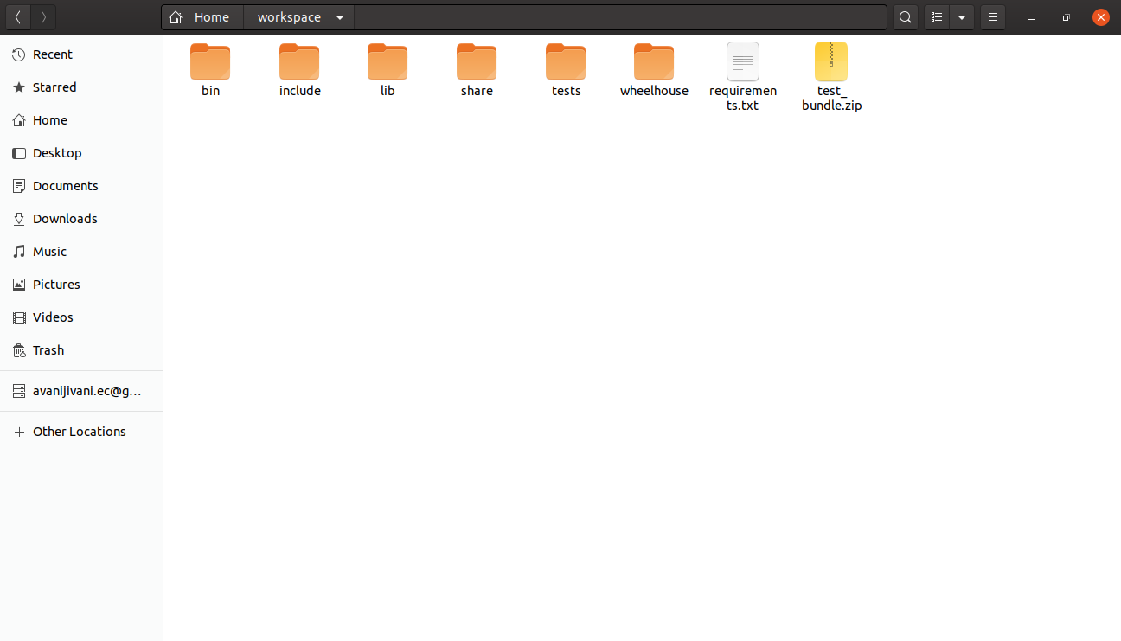

Steps for AWS Device Farm Setup:

1. Sign in to the AWS Device Farm console.
2. If you see the AWS Device Farm console home page, choose Get started.
3. Select “Mobile device testing projects”.
4. Create New Project.

5. If the Create a new run button is displayed, then choose it.

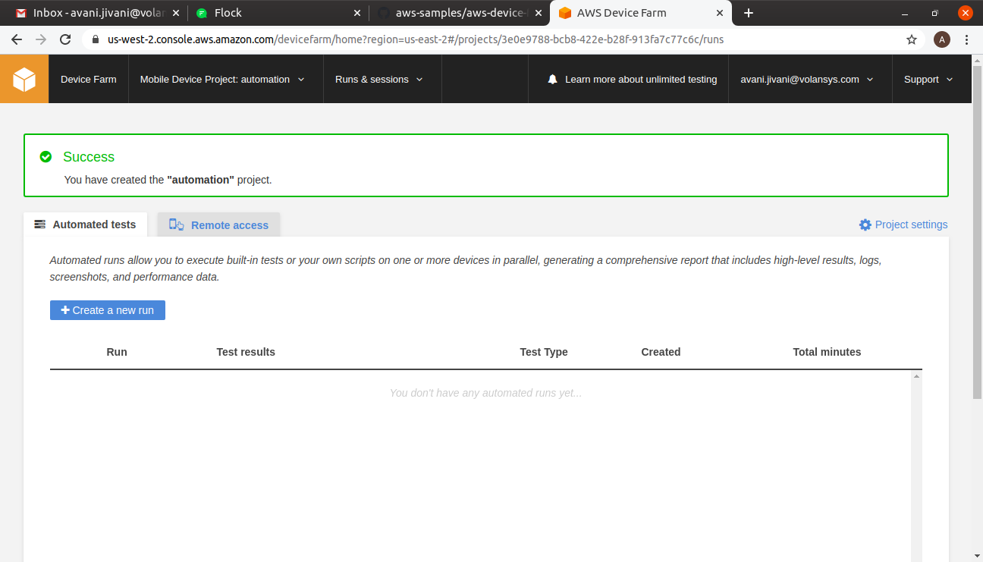

6. On the Choose your application page, choose Application.

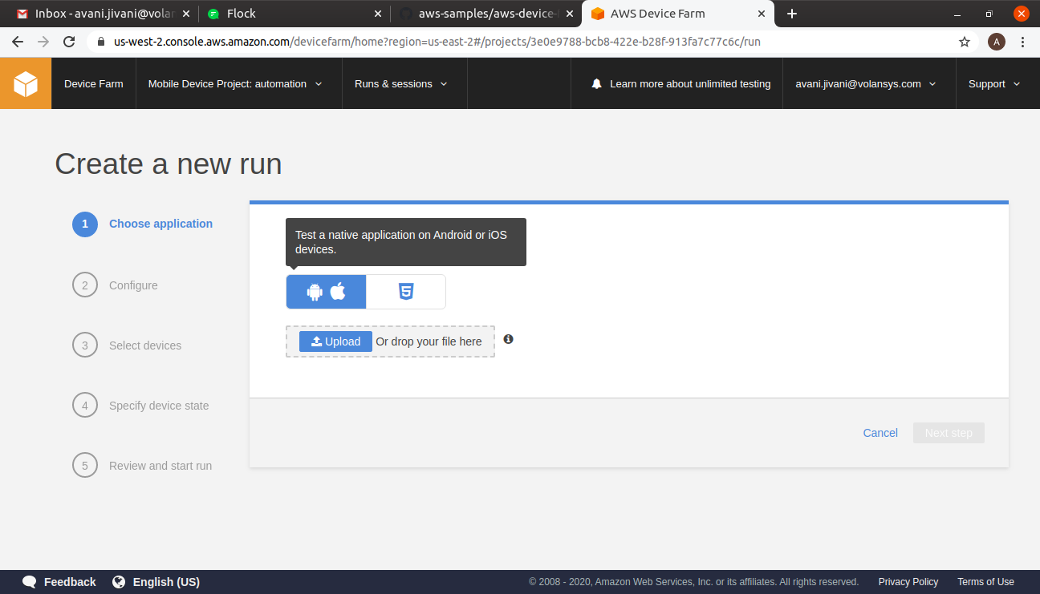
7. Configure your test by choosing Appium Python.

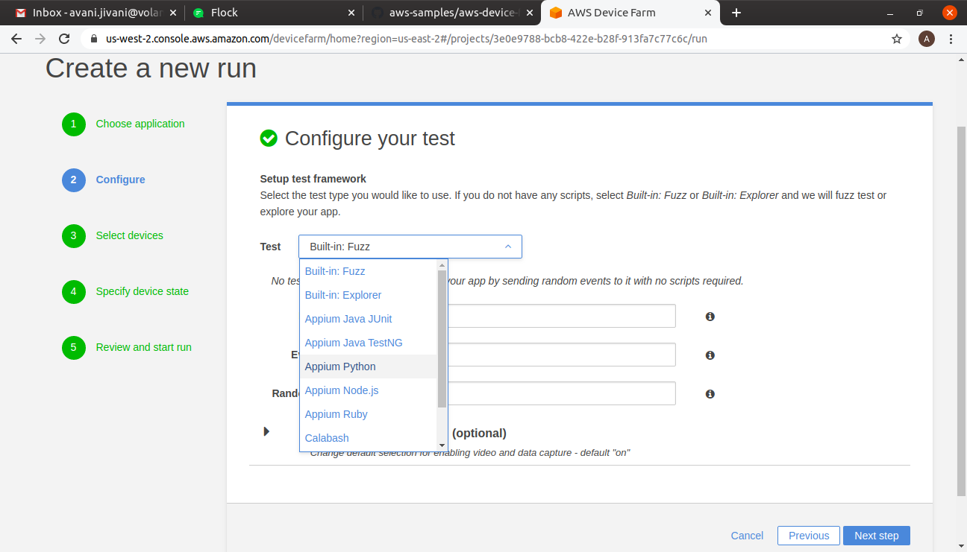
8. Choose Upload to upload your .zip file. Device Farm processes your .zip file before continuing.

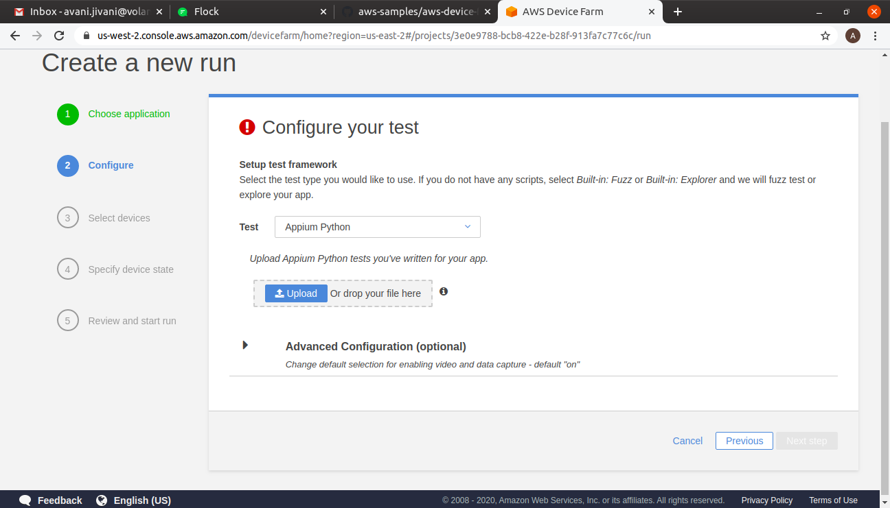

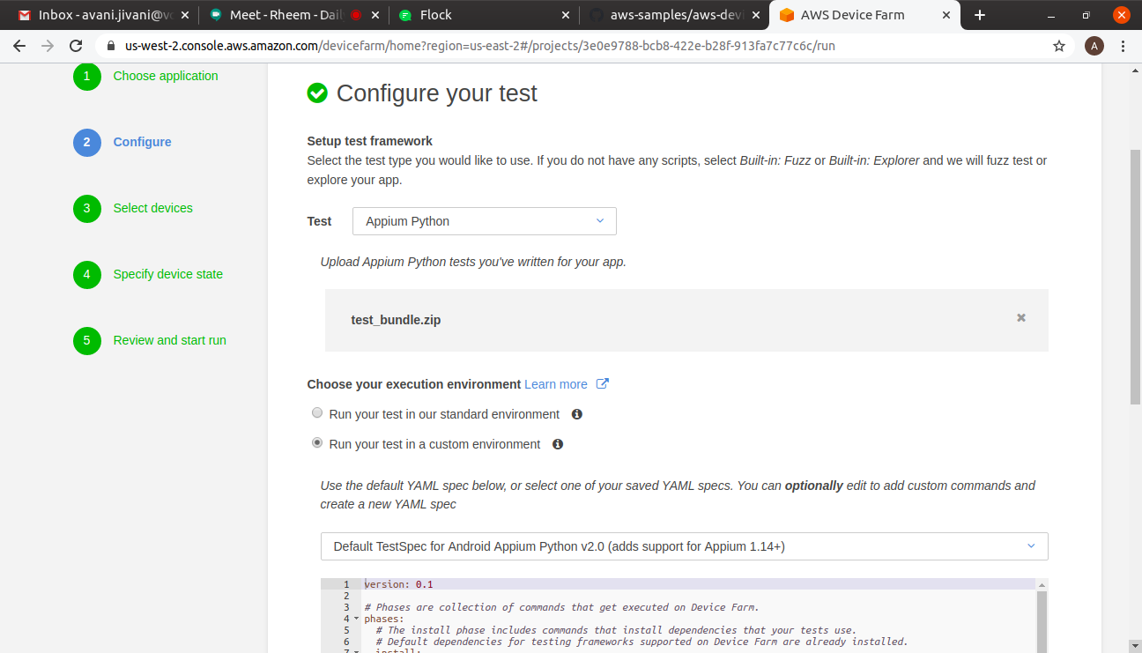
9. Choose your execution environment as “ Run your test in a custom environment”

10. Now Select YAML file and customize it using below steps:

1. Change Python version.
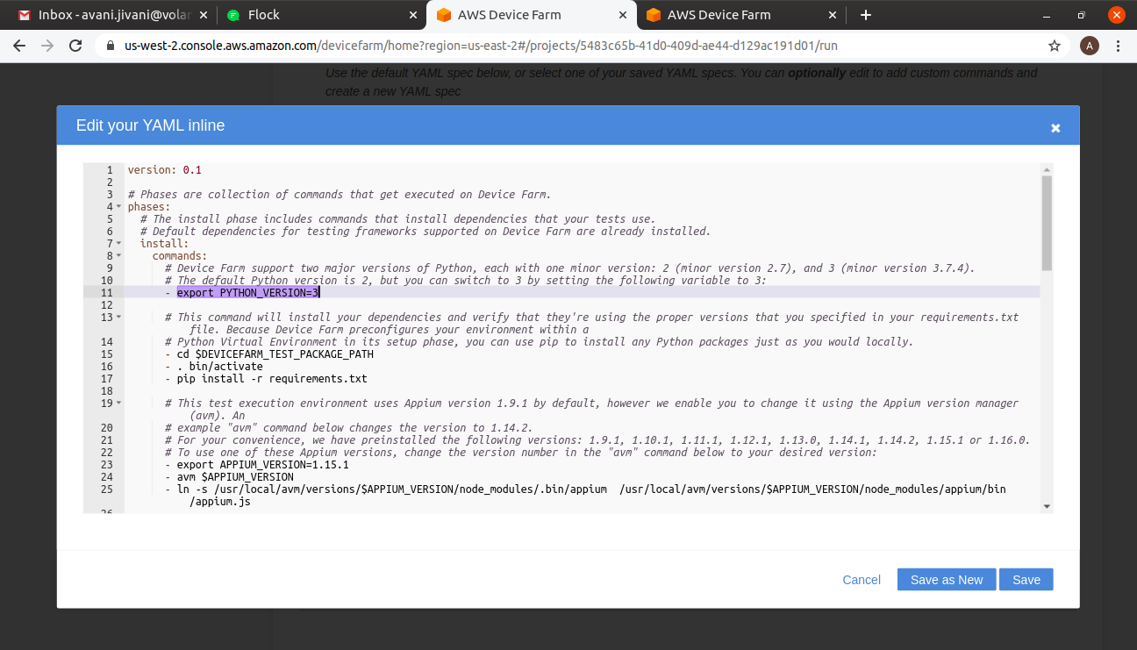

2. Change Appium version.

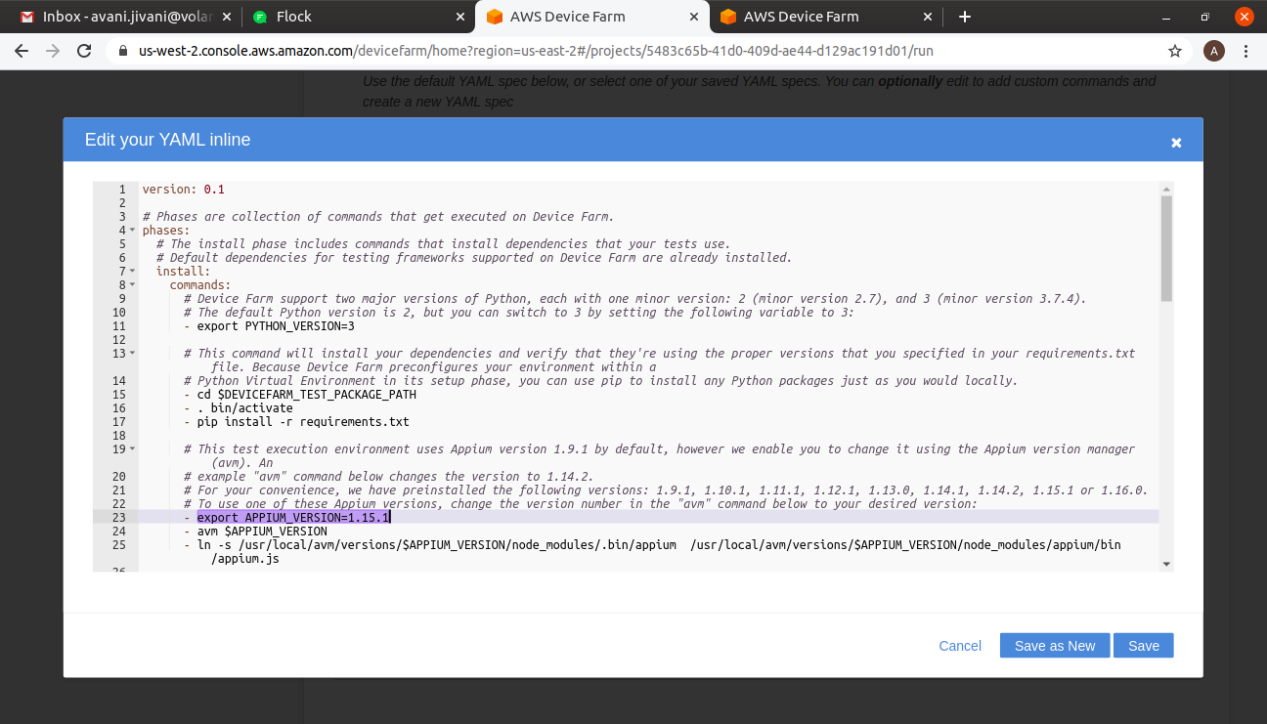
3. Add your working directory path.

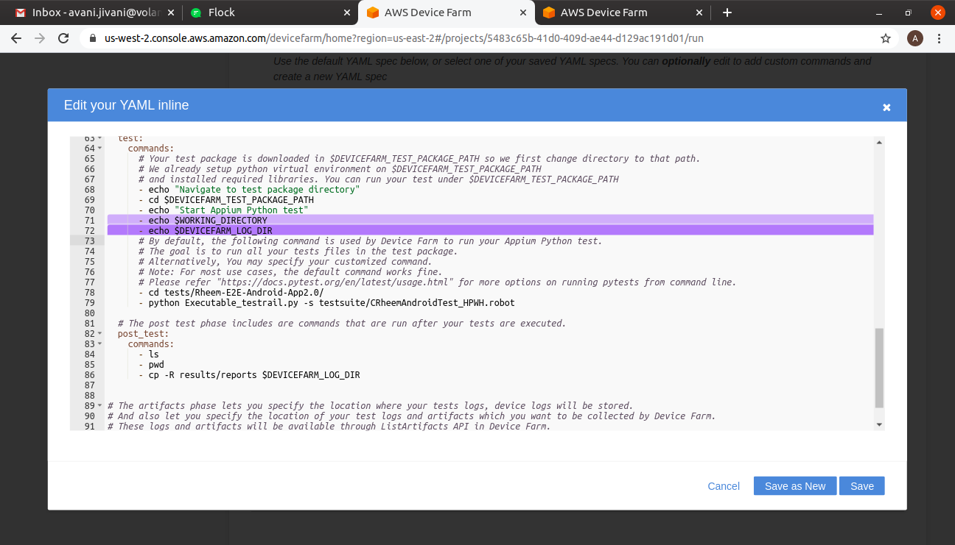

4. Add executable command of automation test scripts.

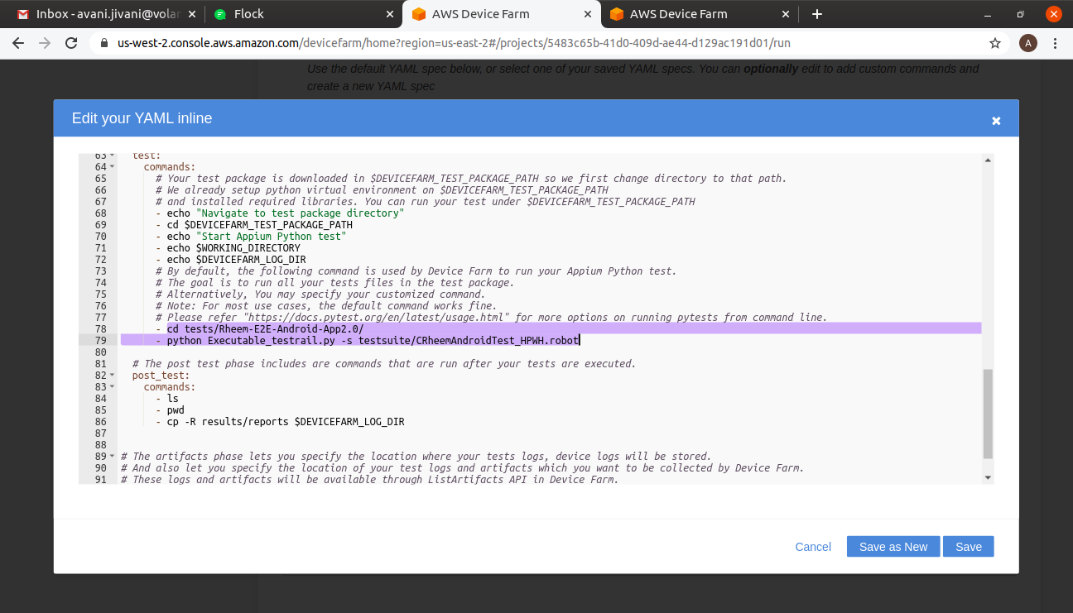
5. Add generated reports directory path.

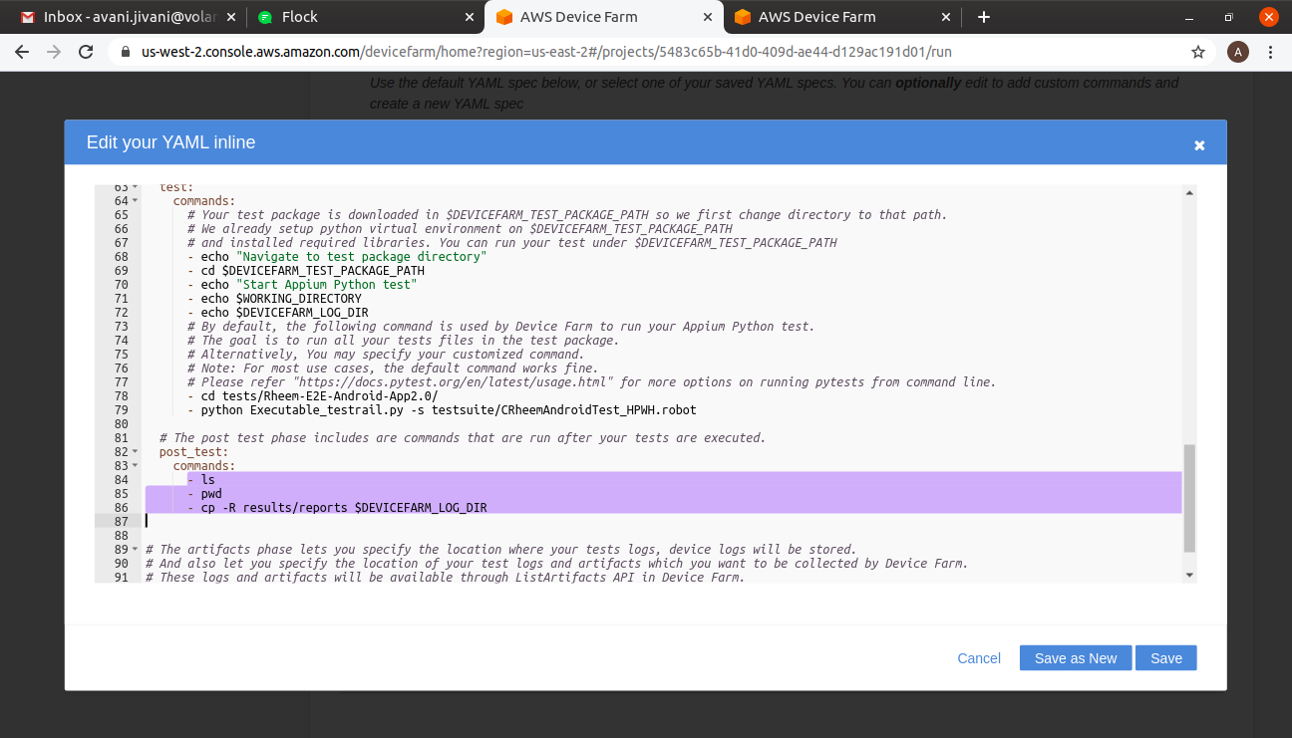
6. After customizing YMAL file Save it as a New file and go to the next configuration.

11. Now select Mobile Device from the Device pool.
- For that create a new device pool and select devices as per your requirement.

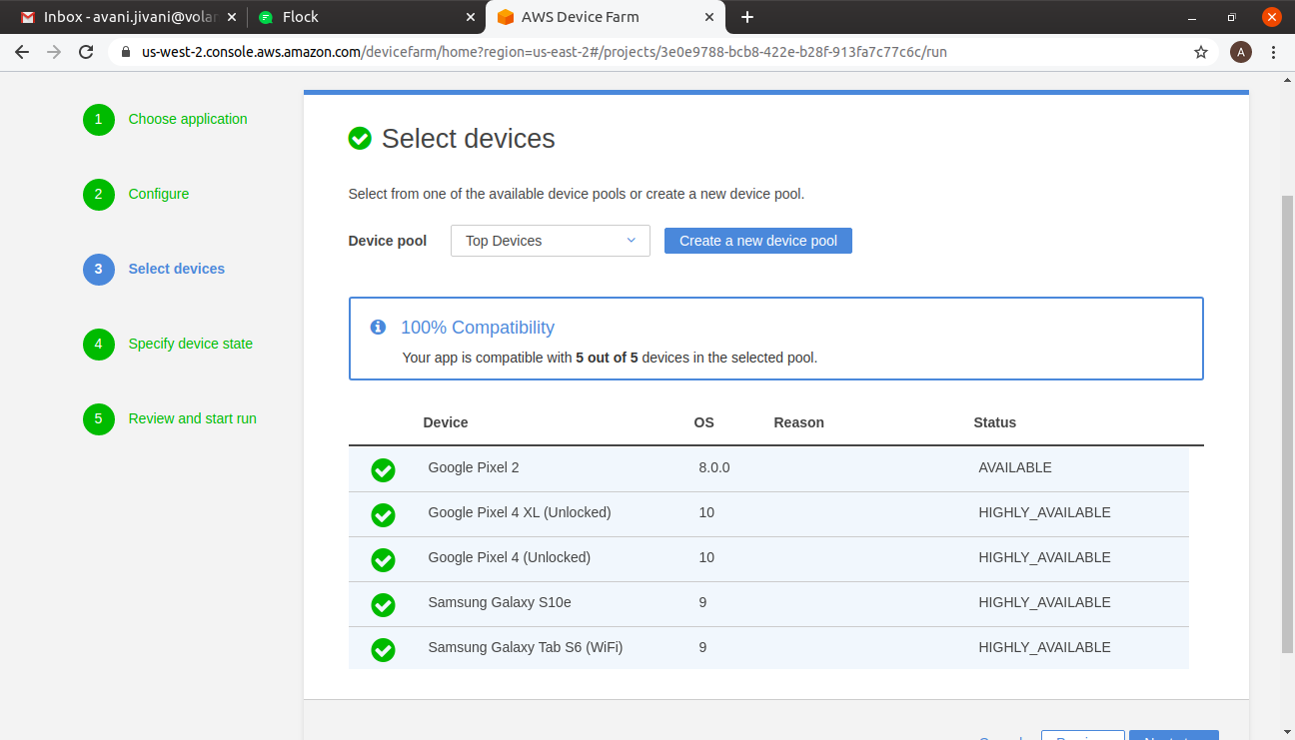
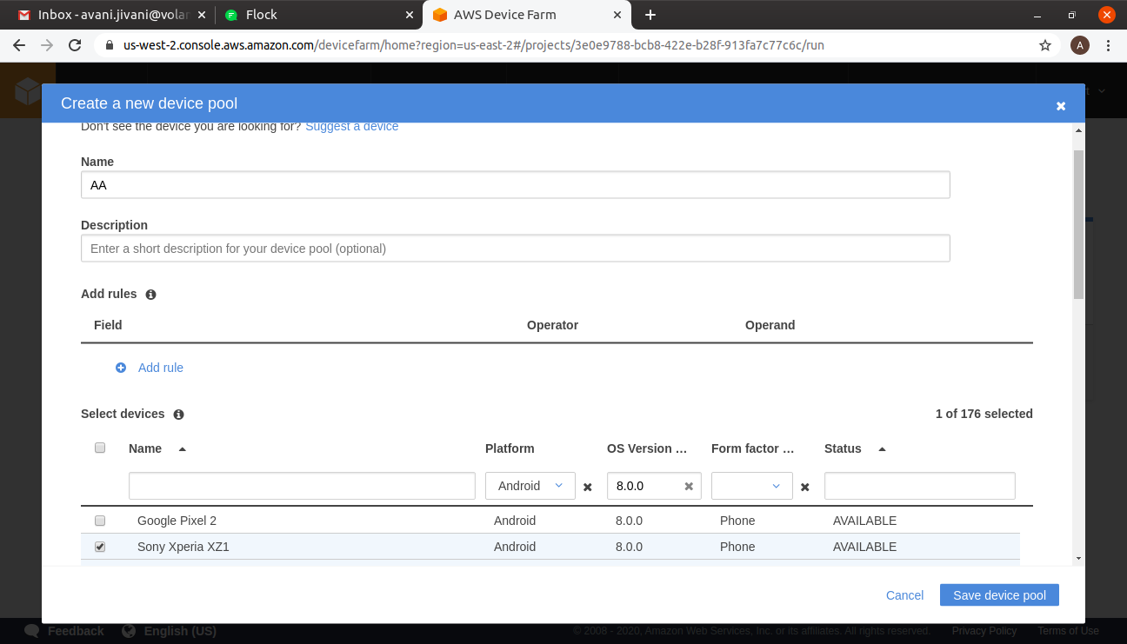

12. Save device pool and go to the next configuration.
13. Set radio states according to your requirement and go to the next configuration.

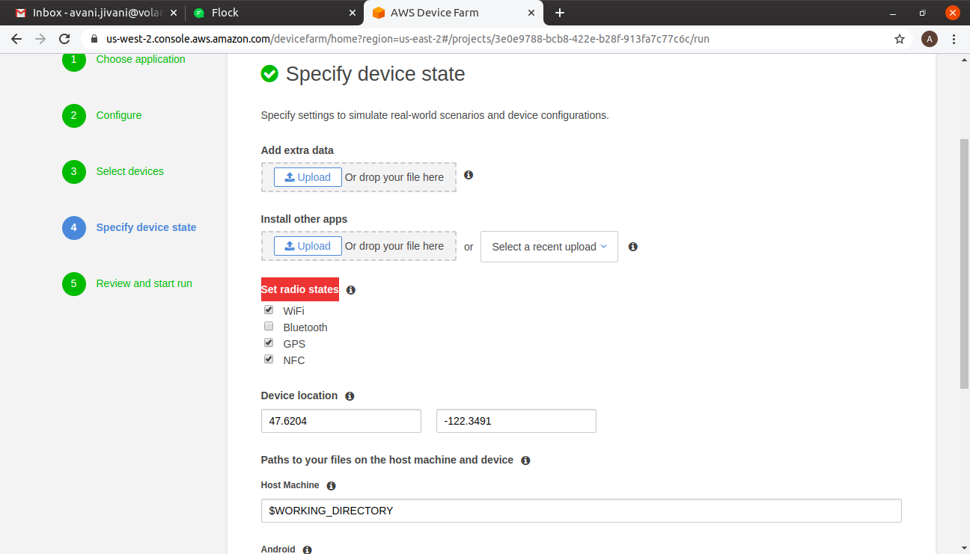
14.Set Execution timeout as per your requirement and then click on confirm and start run.

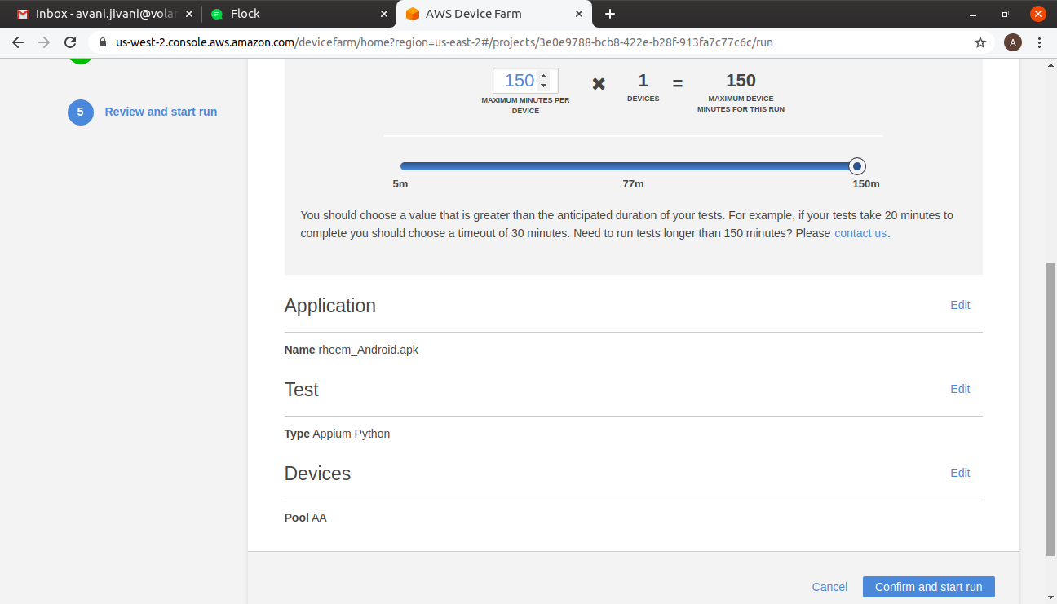
15. After starting the execution go to that Run.

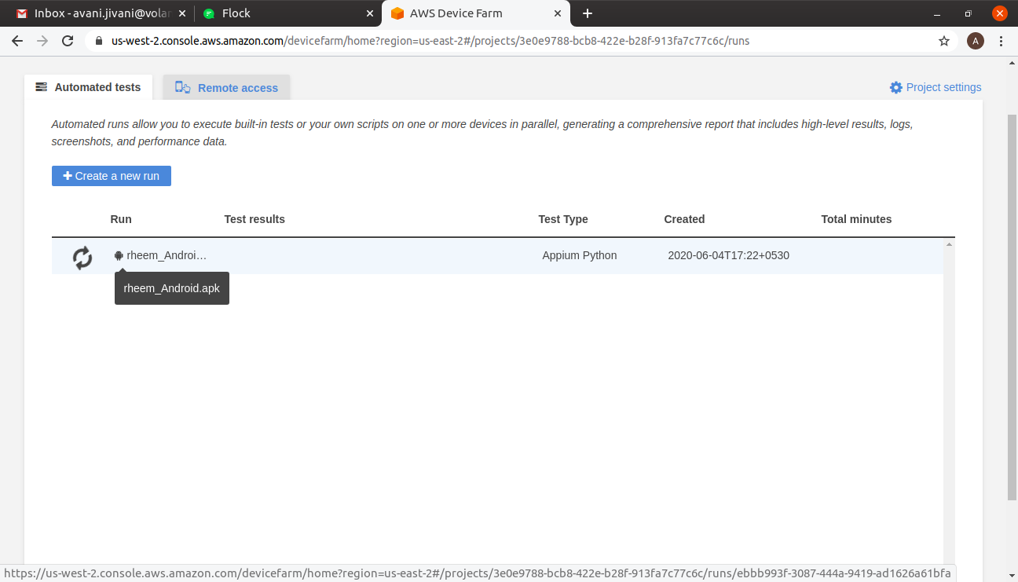
16. Then click on Device name.

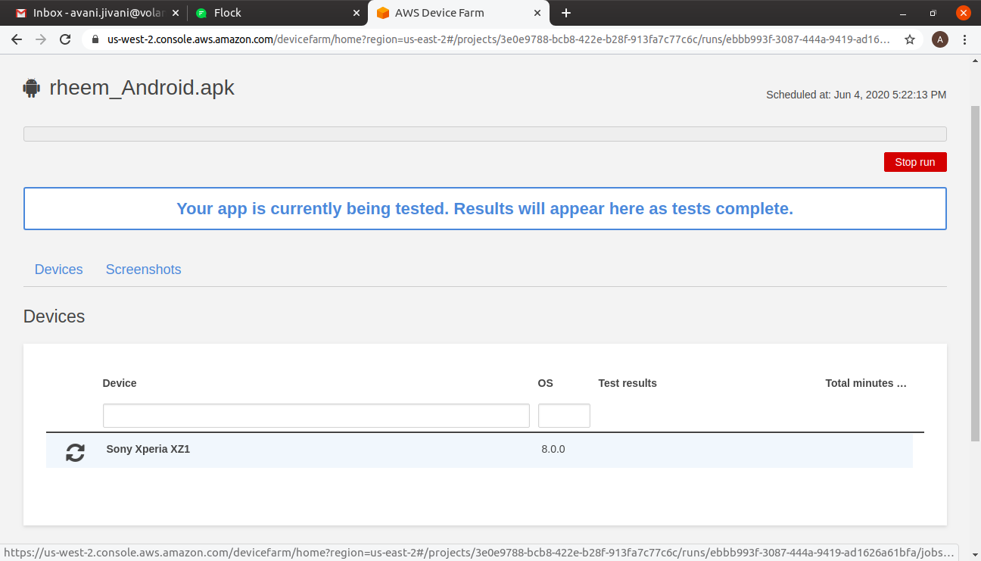

17. After that you can see the mobile device and execution logs on screen.

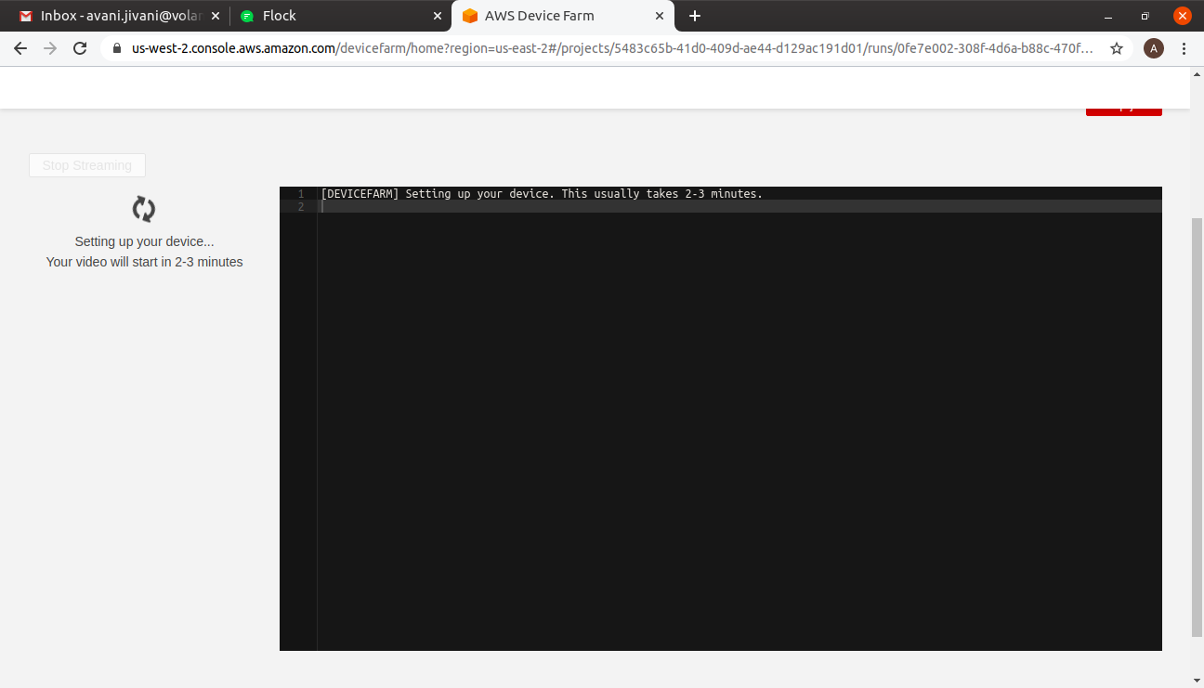
18. After completion of the execution, you can download the test execution video.

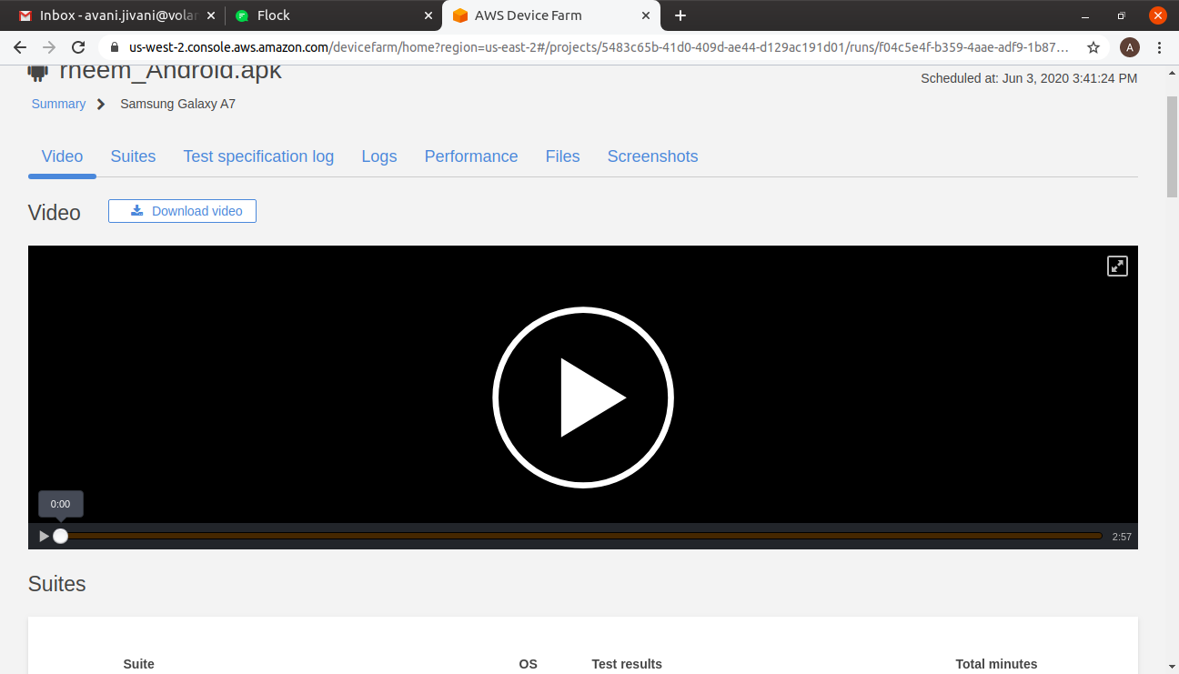

19. Download Test Specification log.

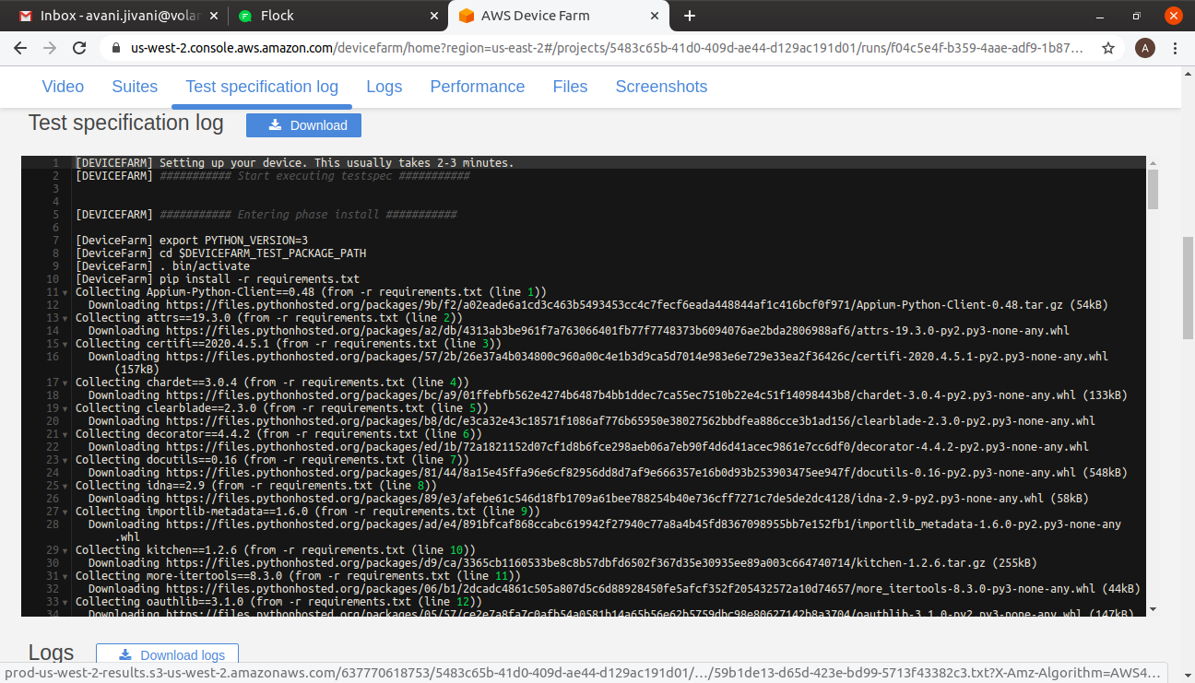
20. Download generated test report files from Customer Artifacts.

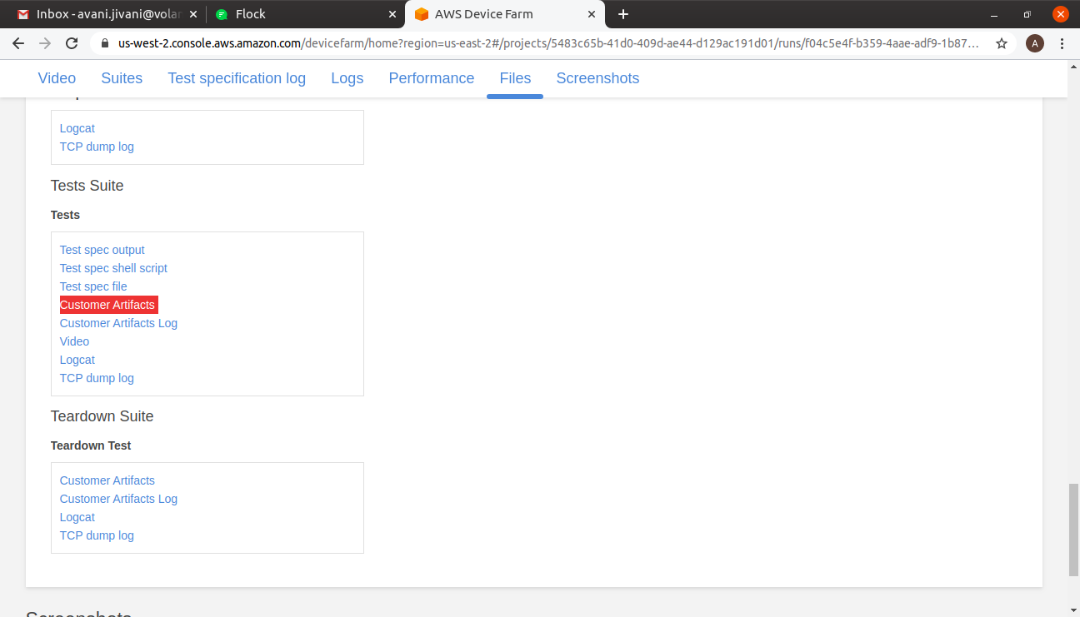

YAML File changes for iOS:

For iOS setup, Same steps should be followed as given above for Android.

Note:

- Don’t Change Anything related to WDA configuration in YAML File.
- Remove the code related to WDA (WebDriver) setup from your test setup config file and then upload that (.zip) on AWS device farm. AWS device Farm provide prebuilt configuration for WDA.
- Use Port Number 4723 in the configuration file as AWS device farm is launching Appium server on the default 4723 Port Number.
- Execution result will be updated in Custom Artifacts directory. Reports could be dowloaded from this location.
- Always Use Highly_Available Devices as It will take less time for setup.

